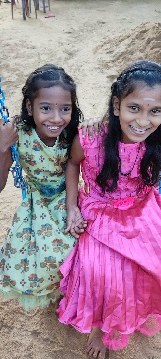
ANNUAL REPORT 2025
HELP has continued its support for disadvantaged children and those experiencing difficulties in the Ampara region of Sri Lanka throughout 2025. This annual newsletter sets out the work we have undertaken in the past year. We hope you find it of interest.
Amman Mahaleer Girls Home
As in previous years, a focus of our work in 2025 has been to support the girls and young women in the Amman Mahaleer Girls Home in Akkaraipattu on the East Coast of Sri Lanka. HELP has supported the girls’ Home for over a decade. It provides a safe haven for 47 young girls and young women aged between 5 and 20, with vocational training being offered to the older girls through dressmaking and IT facilities that HELP was happy to fund in 2012.
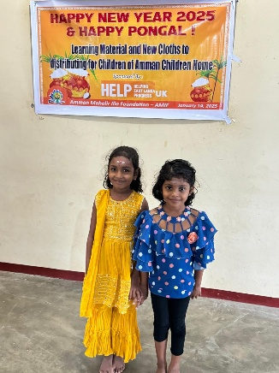
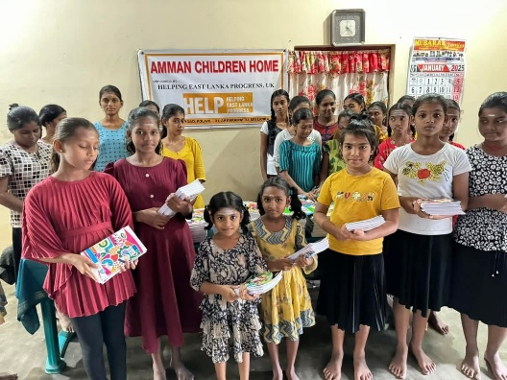
Our support to the Home in 2025 covered a number of areas. We have continued to provide the Home with a monthly bursary that contributes to its ongoing running costs, including food and fuel, and the salaries of the teachers in the vocational centre.
At the start of the year, we provided funding for new clothes and school equipment for the girls in time for their annual Pongal celebration in mid-January. This is an annual four-day festival celebrated by the Tamil community involving traditional cooking, prayers, family gatherings and gift exchanges. The photos show the girls enjoying Pongal in their new clothes and with some of their new schoolbooks.
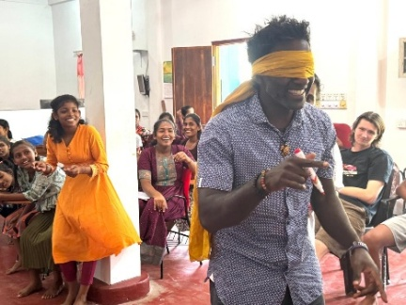
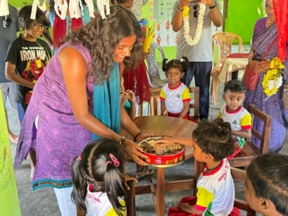
Highlights of the year included visits to the Home by one of our supporters, Tess Hawley and her family in March, and by three of our trustees, Vip, Viji and Senny and their families in August. Tess and her family spent a couple of days at the Home teaching English and generally having fun with the girls. Similarly, Vip, Viji and Senny and their families had a wonderful time, both with the girls in the Home and with the young children at the adjoining pre-school which HELP also supports. The photos give a sense of the fun that was had by all during their visit.
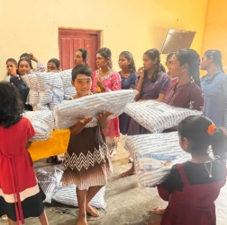
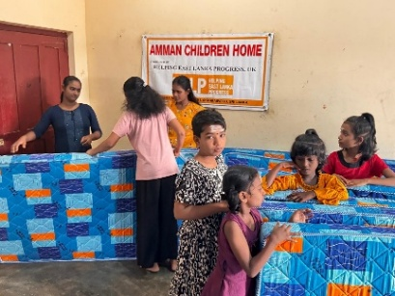
During his visit, Vip discussed the immediate needs of the Home with its Principal, Mr Vamadevan They agreed that the kitchen and girls’ bedrooms needed a full refurbishment, including repainting, new mattresses, pillows, bedsheets and curtains. We were very happy to fund this request and have recently been informed that all of the work has been completed and the equipment purchased. The photos show the girls with their new bedding.
HELP has always had a focus on providing educational and vocational opportunities for the girls and we have continued this year to meet the university fees of four students from the Home. Gaining a university place is an incredible achievement by these young women and testament to the wonderful support they have been given by Mr Vamadevan and his staff. In addition, and as a follow up to her recent visit, Viji is planning to set up regular TEFL lessons for all of the girls in the New Year.
Flood Relief
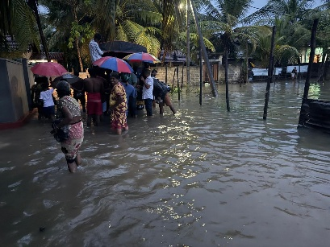
The East Coast of Sri Lanka has been hit very badly by two devastating cyclones in the past year. On both occasions, we were asked to help provide emergency relief to female-headed families in local villages who were particularly hard hit by the floods. Working with the local authorities and Mr Vamadevan, we were very happy to provide funds for dry food parcels (rice, flour, sugar, dhal, soya, noodles and biscuits) for over 100 families. We remain in close contact with Mr Vamadevan should further assistance be required.
We hope the above has been of interest to you and thank you again for your continued support throughout the year. We would like to say a particular thanks to David Bishop and his company, FrontMedia, who kindly maintain our website at no cost (www.helpingeastlankaprogress.org.uk).
Summary Financial Position
We thought it would be helpful to provide a summary of HELP’s income and expenditure for the past twelve months (1 November 2024 to 31 October 2025):
Income (£)
Bank Balance b/f (1/11/24): 9,983
Donations 11,324
Total £21,307
Expenditure (£)
Bursary to Amman Home 6,800
University studies 711
New clothes and equipment 1,212
Flood relief 1,006
Just Giving fees 216
Annual bank charges 309
Total £10,254
Bank balance c/f (31/10/25): £11,053
If you wish to make a donation to HELP, our website has a JustGiving page or direct bank transfers can be made to our account with the Bank of Ceylon (UK) Ltd. The bank details are as follows:
Bank: Bank of Ceylon (UK) Ltd
Name of account: Helping East Lanka Progress
Sort Code: 40-50-56
Account number: 88001077
Thanks again and best wishes to all.
Trustees: Dr Vip Thiagarasah (Chairman); Viji Viyakesparan (Secretary); Andrew Schneidau; Senny Viyakesparan; and Alan Ball (Treasurer)
December 2025
HELP is registered with the Charities Commission in the UK - no 1111363

