PROJECT PROPOSAL
Project Title | : | Setting up “HELP” Pre school & Education Centre
Project Location | : | The village Navatkadu situated within the administrative limit of Alayadivembu
 |  | Divisional Secretariat in Ampara district.
Beneficiaries | : | Pre school children under age group from 3yrs to 5yrs and students attending to
 |  | Grade 01 to Grade 11

Implementation / Monitoring Amman Mahalir Illa Foundation (Amman Children Home) Regd. No GA 3381 ammanmahaleer@gmail.com / +94(0)67 2053937
Project Contact Person : V.Vamadevan / Director / +94(0)77 4210583 / vamadevan.x@gmail.com

NEEDS ADDRESSED.
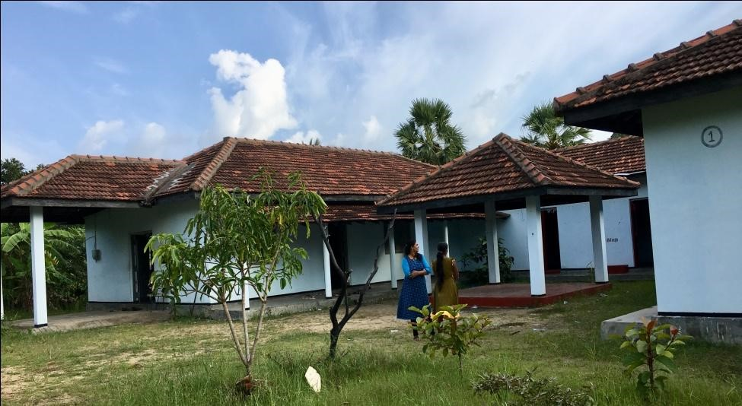
The village Navtkadu is identified in Ampara District with families living under poverty line and the children belonged to these families undergo difficulties without proper access to education. A multi-purpose building was constructed and provided for the benefit of people of this village by the Rehabilitation Organization in the beginning. This building was under control of Military Forces and it was a
Military Camp till today. However, this building has now been released by the Military Forces and opened for the people as result of our continuous effort and pressure.

The need now arises to take up this building and utilize for the social service activities for the community. It is a fact that setting up a pre school is indispensable with the main objective of developing pre school education in this village for the children under the age group from 3yrs to 5yrs.

Besides, there are students of Grade-11 traveling a long distance and attending in evening classes to study Mathematics, English and Science subjects . Therefore evening classes to study subjects such as Mathematics, English and Science could be arranged in this village and conducted using the building.

This building is with a large structure consisting several rooms and it can also be utilized for conducting vocational trainings and other programs for self employment focusing the unemployed males , females and school drop-outs in this village.

We, therefore call upon the Director Board of HELP, London to take over this building and come forward to implement vocational and self employment projects with the main objective of educational development of children and unemployed male and females youths in this poor village.

Detail of Project Cost:

- Preliminary Cost: : Rs. 258,450/-
No. | Detail | Amount Rs.
A.1 | Building repairs. (Repairing doors, windows, Pipe lines and fixing bulbs.) | 35,000.00
A.2 | Purchase of furniture & Learning and Teaching equipments.
A.2.i | Small Chair for Pre School students 20x Rs 570/- | 11,400.00
A.2.ii | Small Table for Pre School students 10 x Rs. 980/- | 9,800.00
A.2.iii | Table for Teachers – 3 x Rs 4,600/- | 13,800.00
A.2.iv | Chair for Teacher - 5 x Rs. 1,050/- | 5,250.00
A.2.v | Office Cupboard – 2x Rs. 15,600/- | 31,200.00
A.2.vi | Making wooden furniture for evening classes students – long Chair (Benches) 15 x 2,800/- | 42,000.00
A.2.vii | Making wooden furniture for evening classes students – long Table (Benches)( 15 x 3,600/- | 54,000.00
A.2.viii | Studying and Teaching equipment ( White Boards, Punches, Notice Board & stationeries) | 15,000.00
A.3 | Cost of Notice Board Displaying information about the Sponsors | 8,500.00
A.4 | Other Cost – (Traveling, Purchasing items such as broomsticks and certain vessels) | 12,500.00
A.5 | Inauguration event Cost | 20,000.00
 | Total Preliminary Cost: | 258,450.00

- Monthly Administrative Cost : Rs. 25,000/-

No. | Detail | Amount Rs.
B.i | Payment for Pre school teachers 2x 5,000/- | 10,000/-
B.ii | Payment for teacher, teaching important subjects. | 10,000/-
B.iii | Other Cost (Stationeries, Communication, Maintenance of building, Monitoring) | 5,000/-
 | Monthly Need. | 25,000/-

It is notable that in case when the organization HELP comes forward to take over the building and provide funding for preliminary cost and monthly need, it can be turned to be as an effective educational centre for educational and self employment opportunities for children and unemployed male and female youths in this village with small contributions made by parents and well-wishers.

The Sketch Photos of this building and letter requesting for support by the Women Societies in this area, are attached herewith .
