HELPING EAST LANKA PROGRESS
Helping East Lanka Progress
Registered Office:
47 Broadfields Avenue
London N21 1AG
+44 (0)208 245 7152
Email: drvipt@yahoo.co.uk
Web: www.helpingeastlankaprogress.org.uk

(HELP)

ANNUAL REPORT
2008

Trustees:
Dr Vip Thiagarasah (Chairman)
Mrs Viji Viyakesparan (Secretary)
Alan Ball (Treasurer)
Andrew Schneidau
Accountant:
Senthu Viyakesparan
Charity no: 1111363

Trustees:
Dr Vip Thiagarasah (Chairman)
Mrs Viji Viyakesparan (Secretary)
Alan Ball (Treasurer)
Andrew Schneidau
Mrs Suneeta Padda-Fletcher



About HELP
Helping East Lanka Progress (HELP) was set up by Dr Vip Thiagarasah in August 2005 to relieve the suffering of victims affected by the devastating tsunami of December 2004 on the East Coast of Sri Lanka. It received charitable status from the Charity Commission on 19 September 2005.
The aim of HELP is to provide assistance to the families, and specifically the children, on the East Coast of Sri Lanka who have suffered as a result of the tsunami. HELP operates on the simple principle that all funds raised will be spent on the projects identified by the trustees. Any expenses and administrative fees incurred by HELP are met by the trustees personally and everyone involved with HELP offers their services on a voluntary basis.

Review of the year to end-June 2008
The situation on the East Coast of Sri Lanka has improved significantly since our first visit in the aftermath of the tsunami of December 2004. Most families are now in proper housing, the road network has improved and there are some encouraging signs of the local economy picking up. However, the problems remain immense. The region has received only limited government funding to restore the public infrastructure. Schools and hospitals remain under-funded with limited money for equipment and salaries; there is no state or other provision for those orphaned by the tsunami or the civil war; and there is the daily frustration of intermittent electrical and communication services. And, although a predominantly Tamil and Muslim region, it is administered by the Singhalese government with a heavy military presence. This imposes a daily constraint on the normal lives of the population.

Notwithstanding this challenging environment, we are very pleased to report that, thanks to the continued generosity of our donors and the hard work of all involved, HELP has had another very successful year. Our Trustees visited the East Coast in November 2007 and June 2008 to monitor existing projects and to identify new opportunities. What follows is a summary of the progress we have made in the past year and some of the challenges we face in 2009.

Komari School Educational Scholarship Scheme
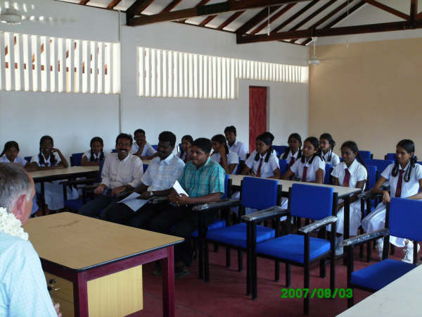
The educational scholarship scheme we are running for students at the school in Komari is one of our most successful projects. A new term recently started with 72 students enrolled in the scheme and there are more lined up to join next term. We met the Principal of the school and the students who are benefiting from the scheme on both visits during the past year. The Principal was delighted to report that all students were making progress and specifically that one of the earlier students had gained a place at university to study dentistry, which was an incredible achievement. On the latest visit, the students staged a marvelous English speaking and dance show and we were delighted to donate some sports equipment to the school.
The educational scholarship scheme is being generously financed by the Amman Temple in West Ealing, to whom we are most grateful. With their assistance, we are delighted to be able to commit to the scheme for a further year.

HELP also pays the salaries of the two women English teachers at the school, who had previously worked on a voluntary basis. We have also agreed to finance the purchase of equipment for the school science laboratory (which consists currently of a couple of test tubes!).

The “Little Flowers” post-school facility for children in Thirikuvil

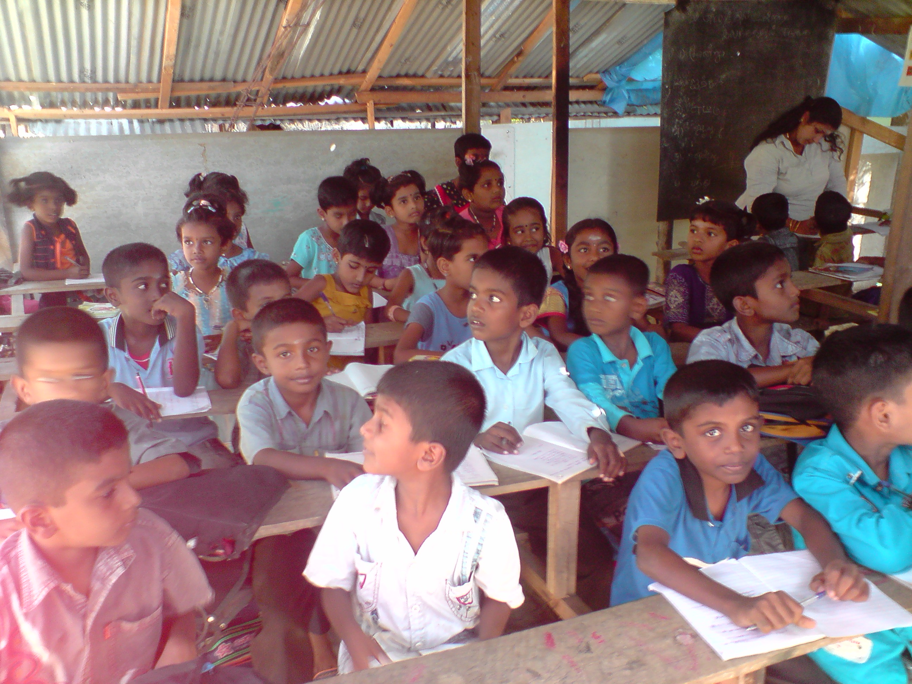
We mentioned in the last newsletter that, with the assistance and drive of a local university lecturer whom we met on our first visit to Sri Lanka, we have funded the establishment of after -school classes for junior school children in Thirikuvil. This has been an unqualified success with 150 of the poorest children in the village attending 2-hourly after-school classes in Tamil, English, Maths and Social Science from Monday to Thursday each week. Exam results at the local school have soared. Our money has paid for the construction of four ‘classrooms’ and meets the cost of the five teachers. Our Trustees were privileged on their most recent visit to attend the end of year prize-giving and to buy some whiteboards for the classrooms. We hope in the next six months to be able to fund more substantial classroom facilities for the school as some land has been made available and there are more children wishing to participate in the scheme.

Swami Vipulananda Boys’ Home
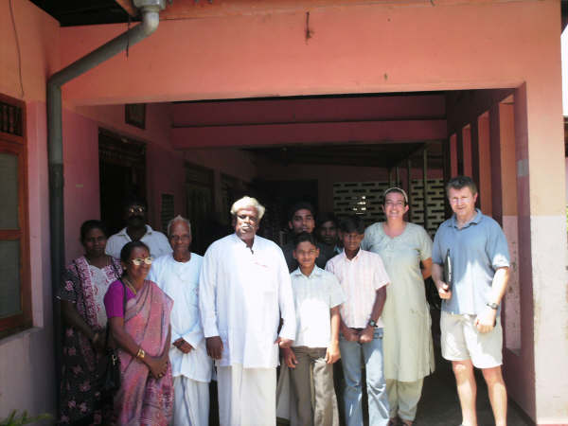
The Swami Vipulananda Boys’ Home in Akkaraipattu, which HELP has been supporting for 3 years, provides a safe haven to 29 boys orphaned by the tsunami and the civil war. It is depressing to report that each time we visit, the situation of the home has become increasingly more difficult. It receives no government support and its charitable supporters have fallen away as memories of the tsunami fade. When we met the Principal in June, the Home was struggling to feed its children as a result of significant increases in the cost of basic commodities. Whilst on the visit, we bought a lorry load of rice for the Home which would feed the boys for one month and agreed to double our monthly bursary to £400. This will meet the total monthly cost of the Home’s food and ongoing expenses. We are delighted to continue to support the Principal, who does an extraordinary job in the most difficult of circumstances.
Amman Mahaleer Girls’ Orphanage
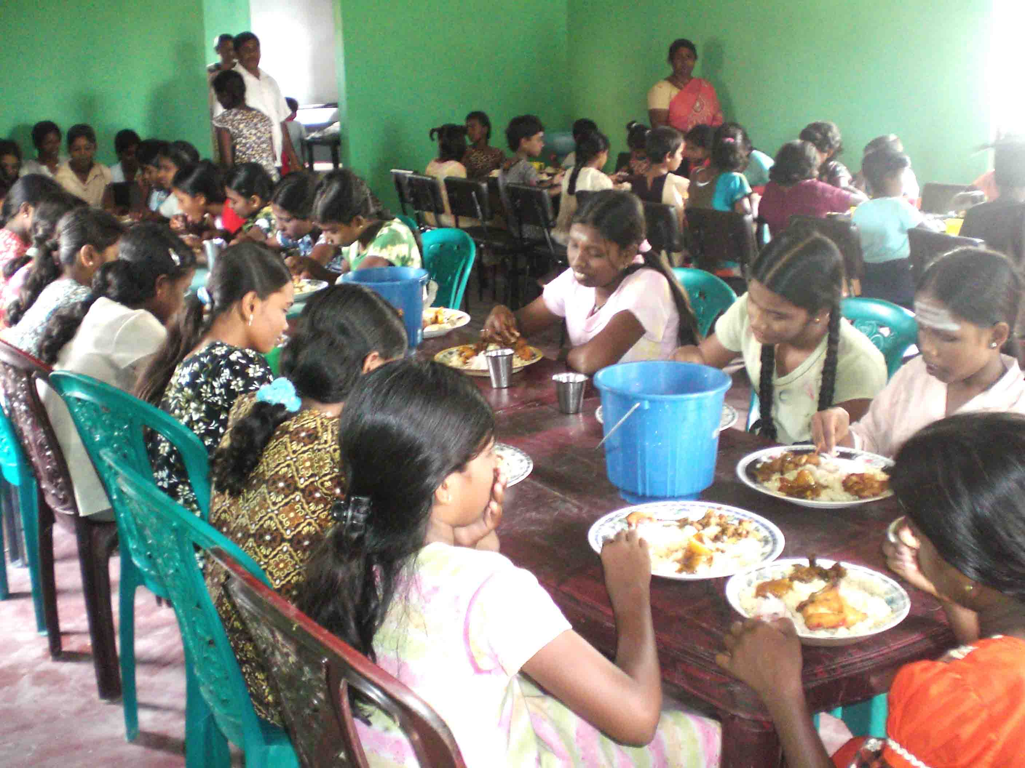
HELP has supported the Amman Mahaleer Girls’ Orphanage in Akkaraipattu for three years. The orphanage has 53 girls who, when we first visited the orphanage, were sleeping, eating meals and having lessons on the floor of the home. With your support, we have been able to provide chairs, tables, beds and mattresses for the children as well as school socks, shoes and kitchen equipment.
The orphans moved into a new building in March 2008 but funds ran out before the construction could be completed. This left the girls without running water, electricity or any kitchen and dining facilities.
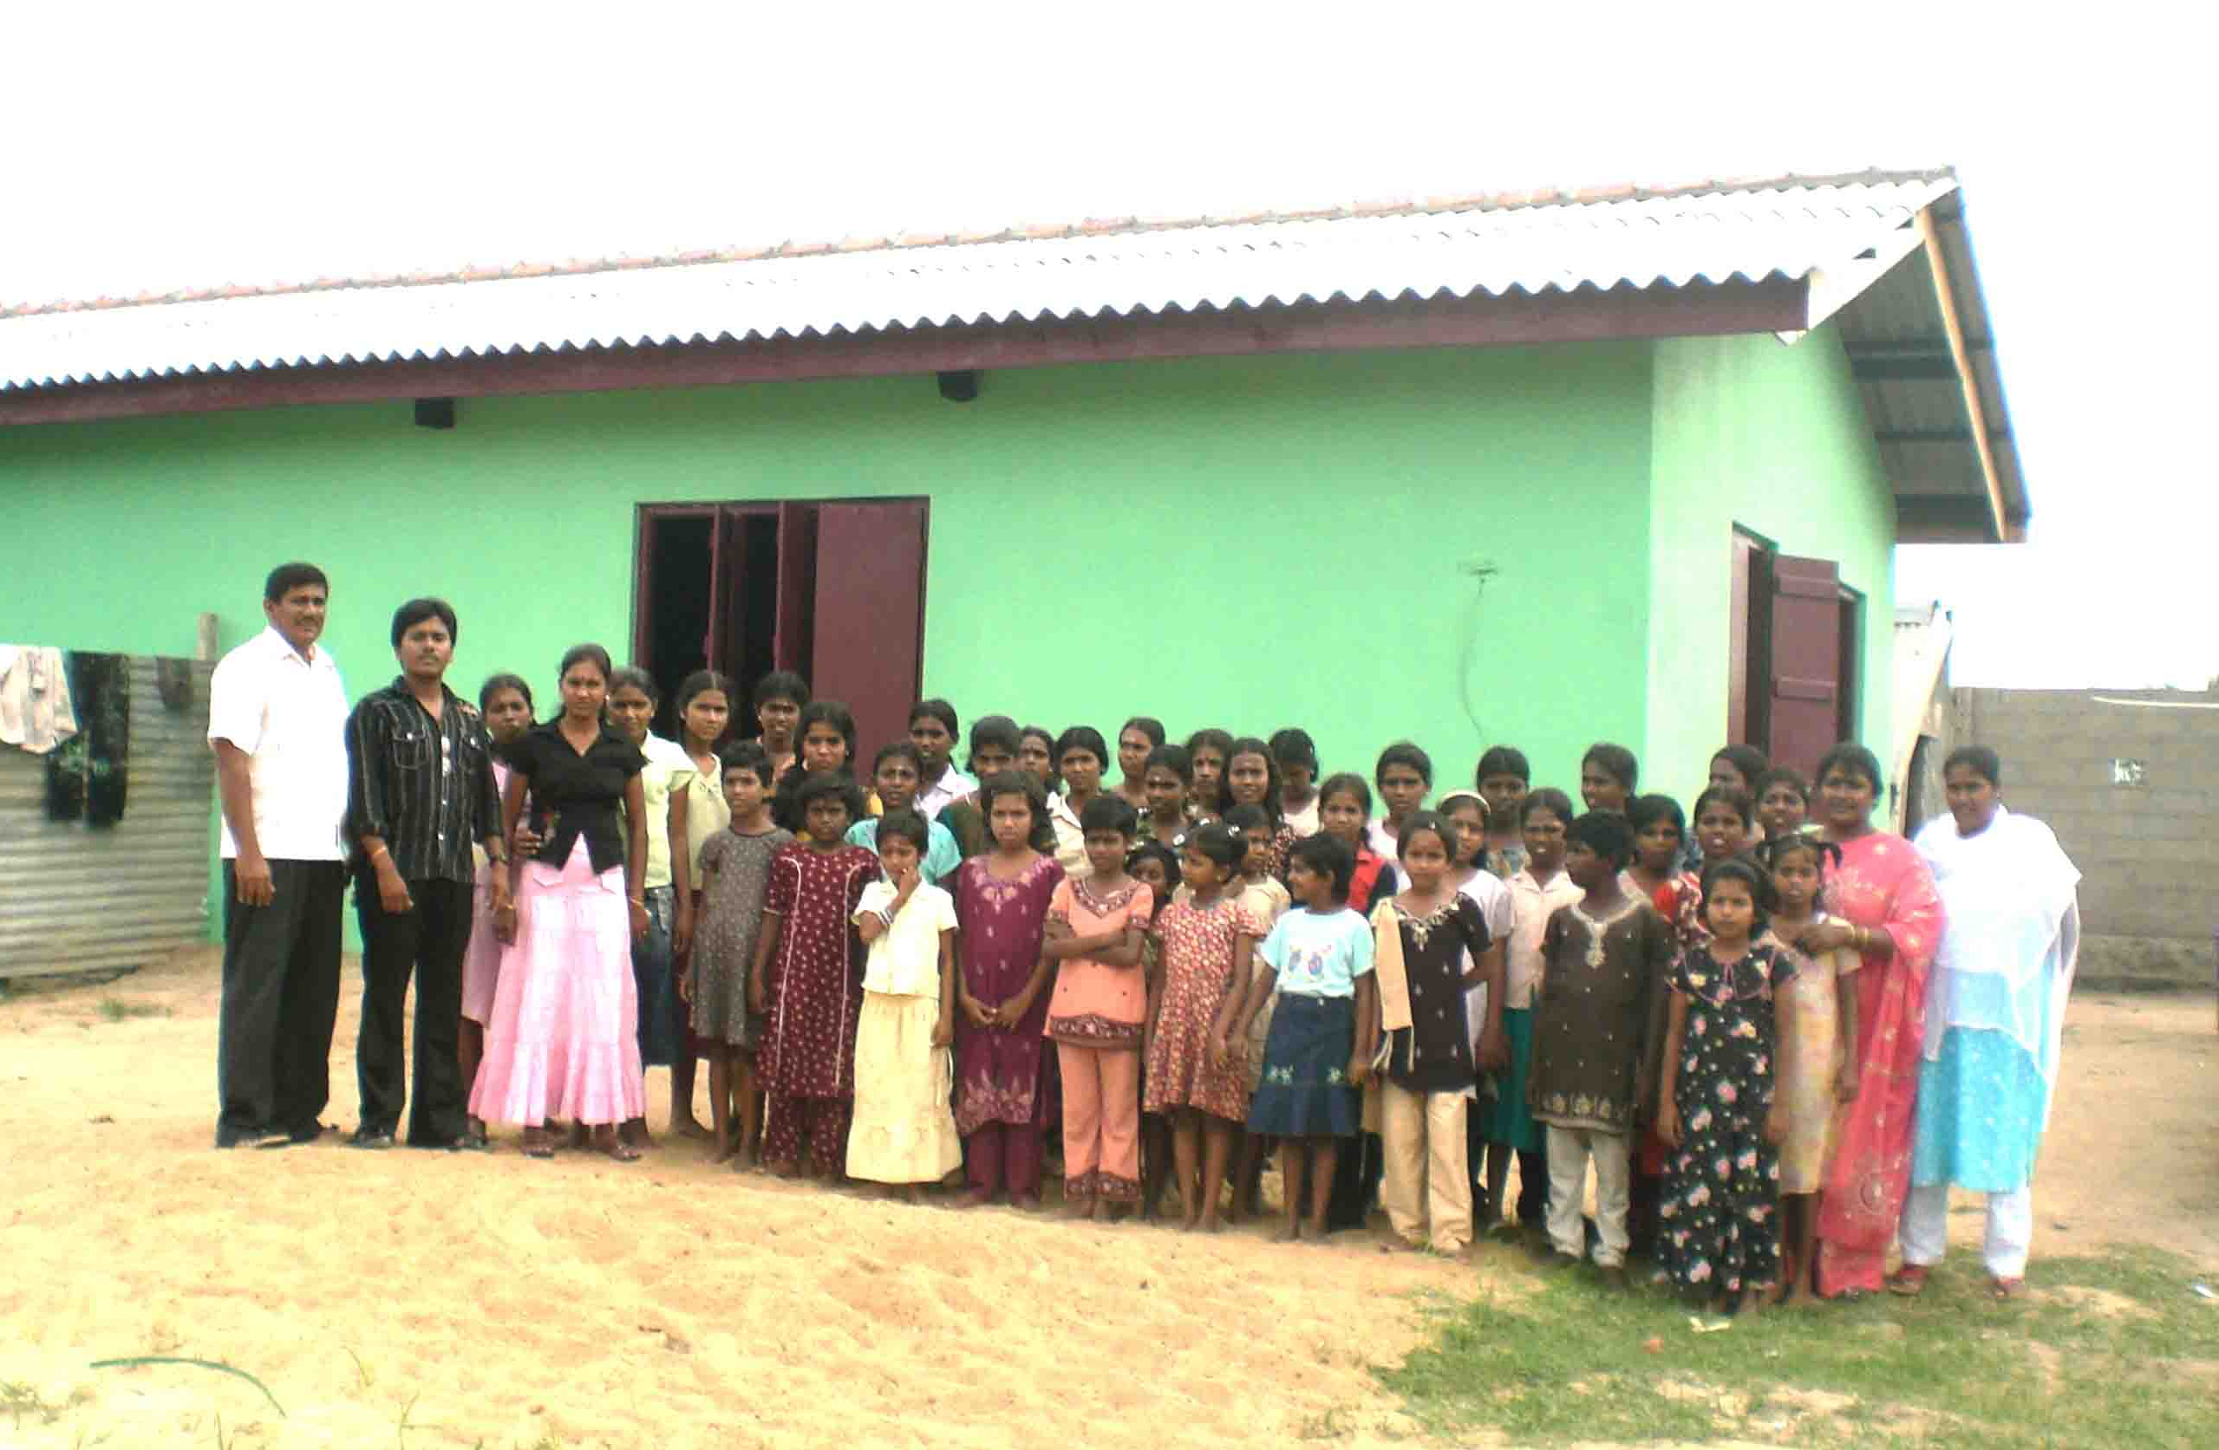
We undertook in our visit in November 2007 to complete the kitchen/dining facility and to install electricity and we are delighted to report that both have been completed. The photo above shows the girls eating in the new dining room …
Our aim in 2009 is to provide running water to the orphanage and for the showers and toilets to be completed and connected. In the meantime, three outside temporary showers/toilets are the only facilities that the girls have.
The orphanage also benefits from 5 teachers who have worked on a voluntary basis for the past 4 years. The personal circumstances of these teachers are very difficult but thanks to a very generous donor, we have been able to commit to meeting their salaries for a year.
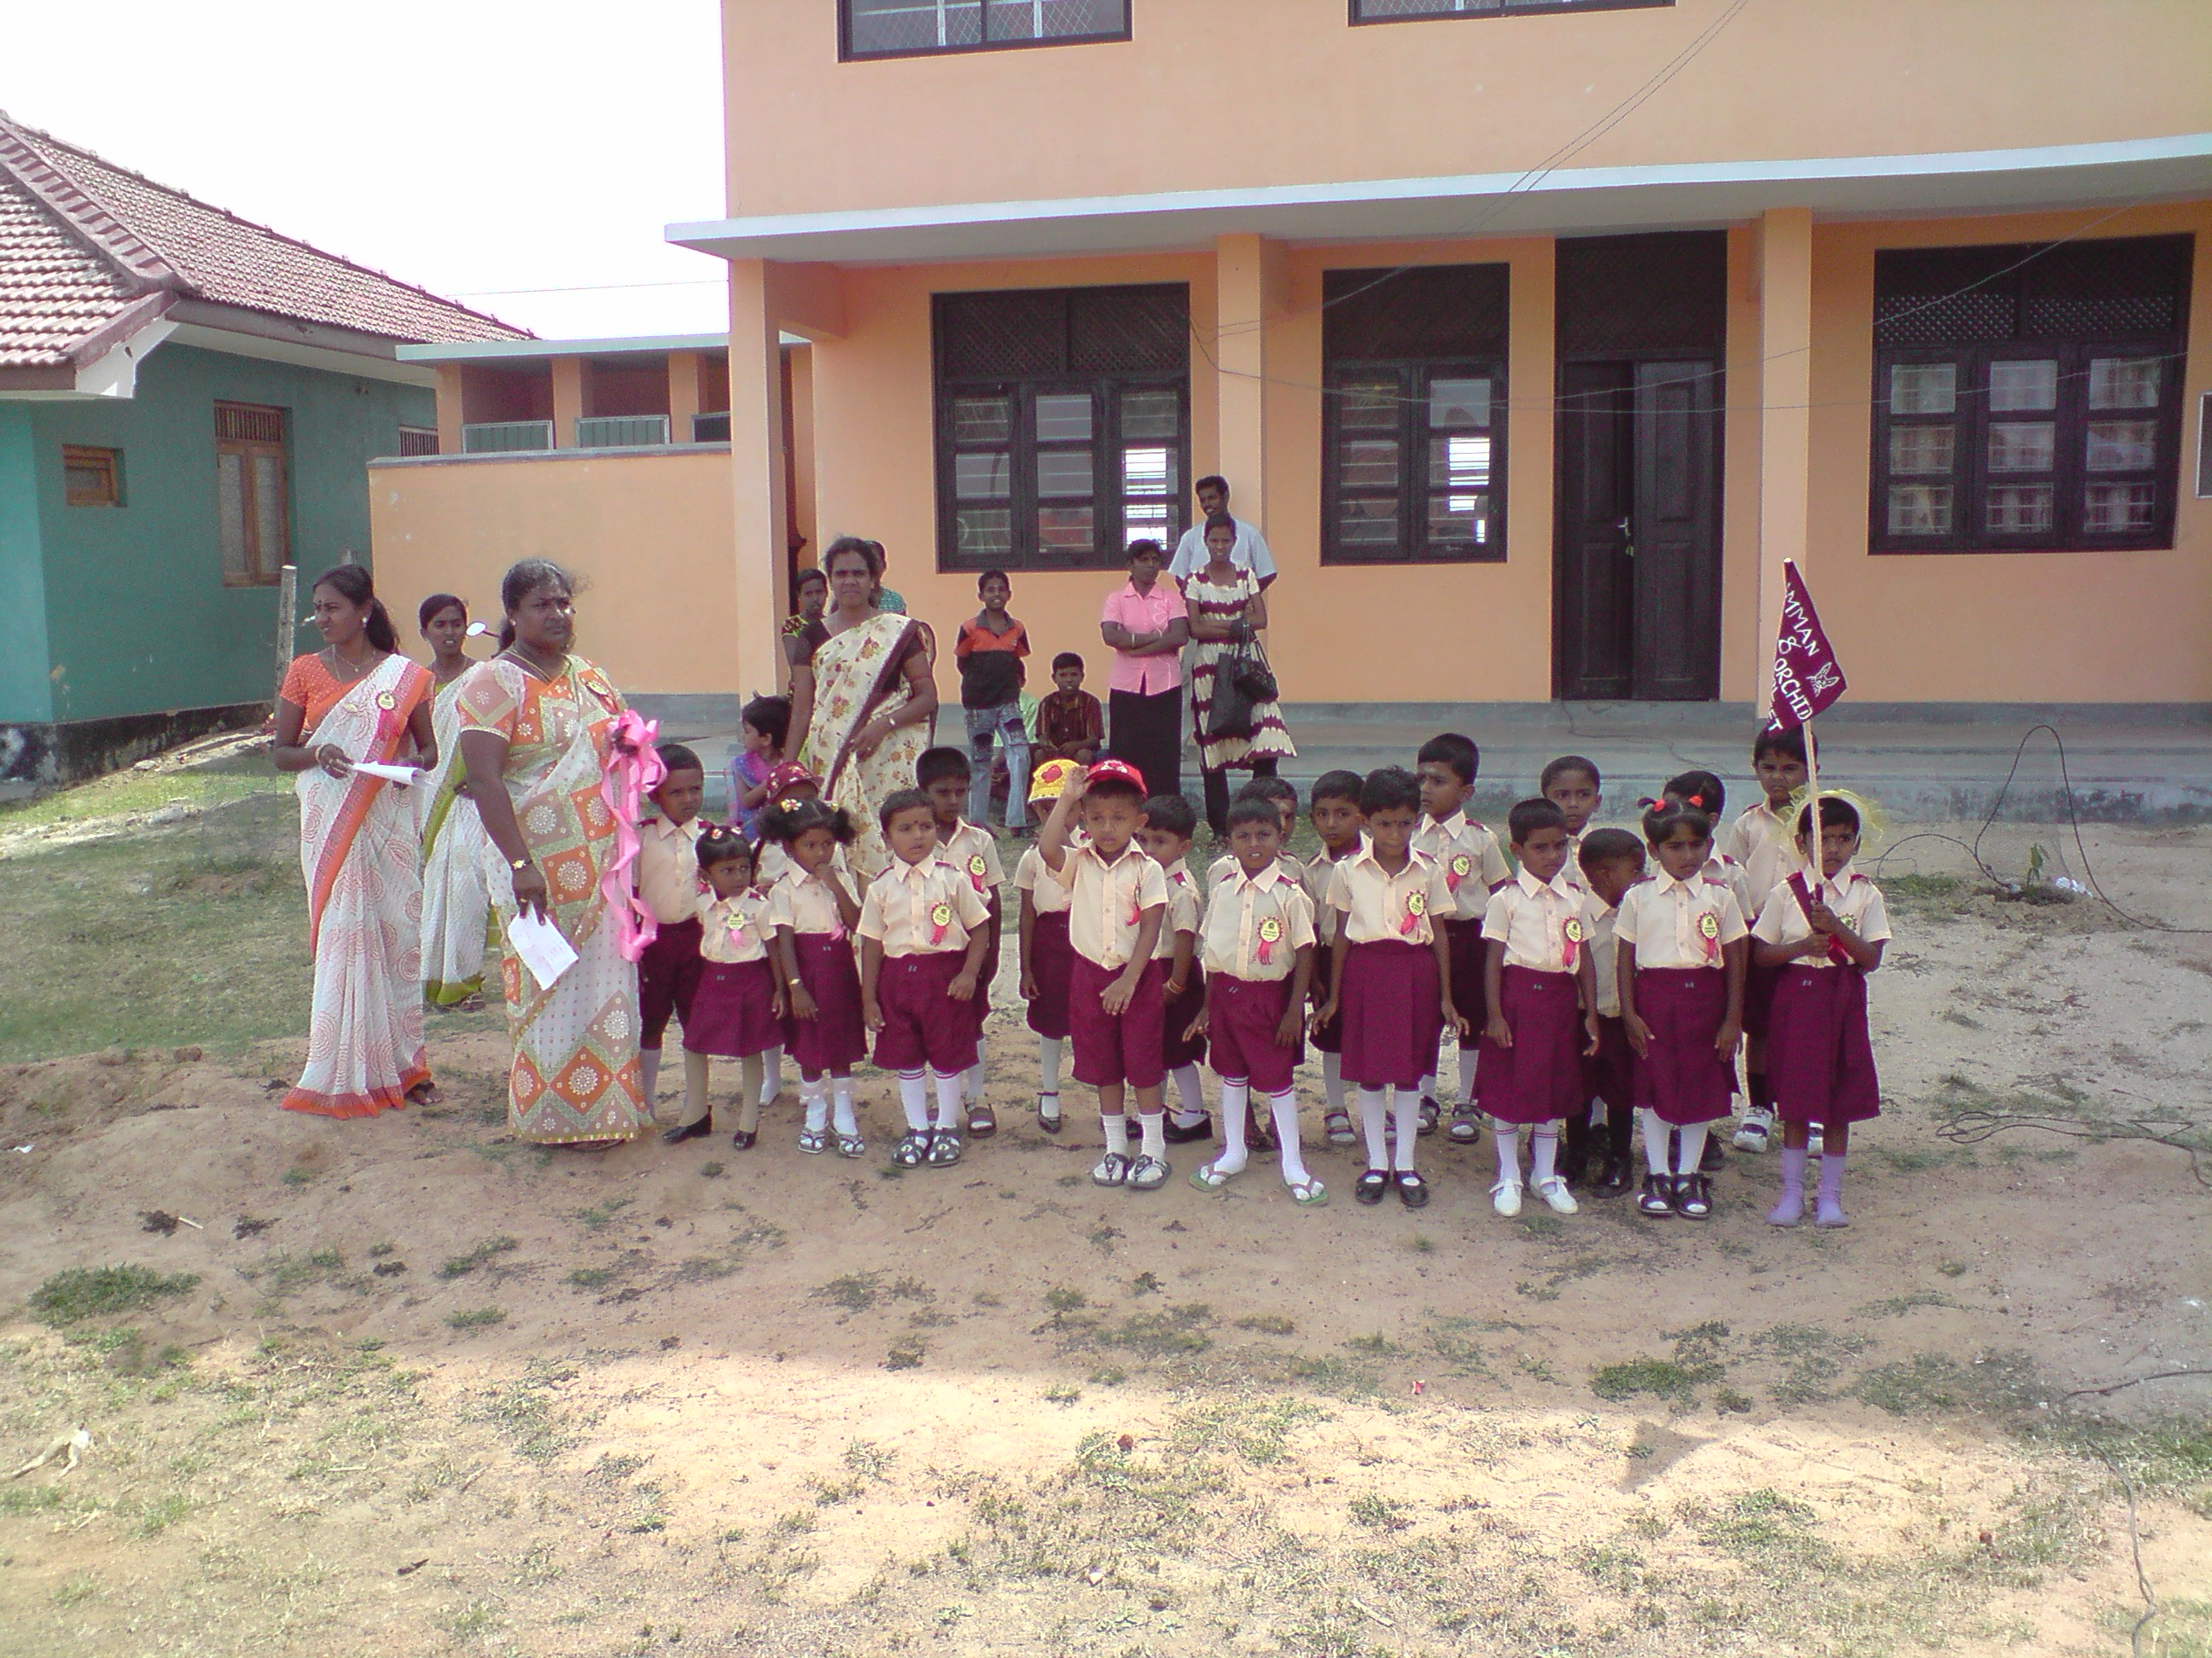
Amman Mahaleer Nursery School
Attached to the girl’s orphanage is a small nursery school for 28 orphaned nursery school children. We have previously bought tables and chairs for the nursery and were invited to their annual sports day in June. This was a really fun afternoon and it was great to see the toddlers have such a great time.
We have been asked if we can fund the three teachers at the school who are currently volunteers and also help fund a children’s playground for the school. Again, this is another main project for HELP in 2009.

Micro-finance schemes in Pottuvil and Urini
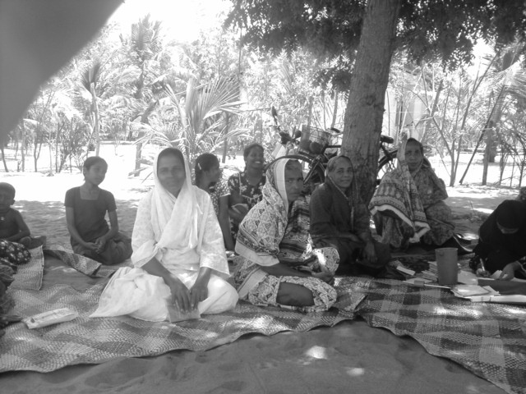
In the course of the past two visits, HELP’s trustees were introduced to a major NGO operating in the East which set up and administered micro finance schemes in remote villages. These schemes provide small loans at minimal interest rates to women who would otherwise have no access to finance. The women form a community of 20 and run the scheme themselves, including granting the loans. The loans are used by the women to start small businesses (such as egg production, stitching, rug weaving, fishing net repairs etc), which generate income to support their families and to repay the loans. We have been delighted to fund two such schemes which support 40 single women in Pottuvil and Urini.
We receive regular reports on the progress of the two projects and have been very impressed with the results of both so far. We believe that these provide life-changing opportunities to single mothers with families which are otherwise simply not available in the region. We will endeavour to increase our support for the projects in 2009.
Vinayagapuram Displaced Families Camp

During their June visit, our Trustees learnt from a very good friend, Annette Beuth, about the plight of 45 families who had been transferred to a displacement camp in Vinayagapuram from their homes in Jaffna and Trincomalee as a result of the ongoing civil war. Annette had spent the previous two weeks working in the camp and told us of the very difficult circumstances the families had to cope with.
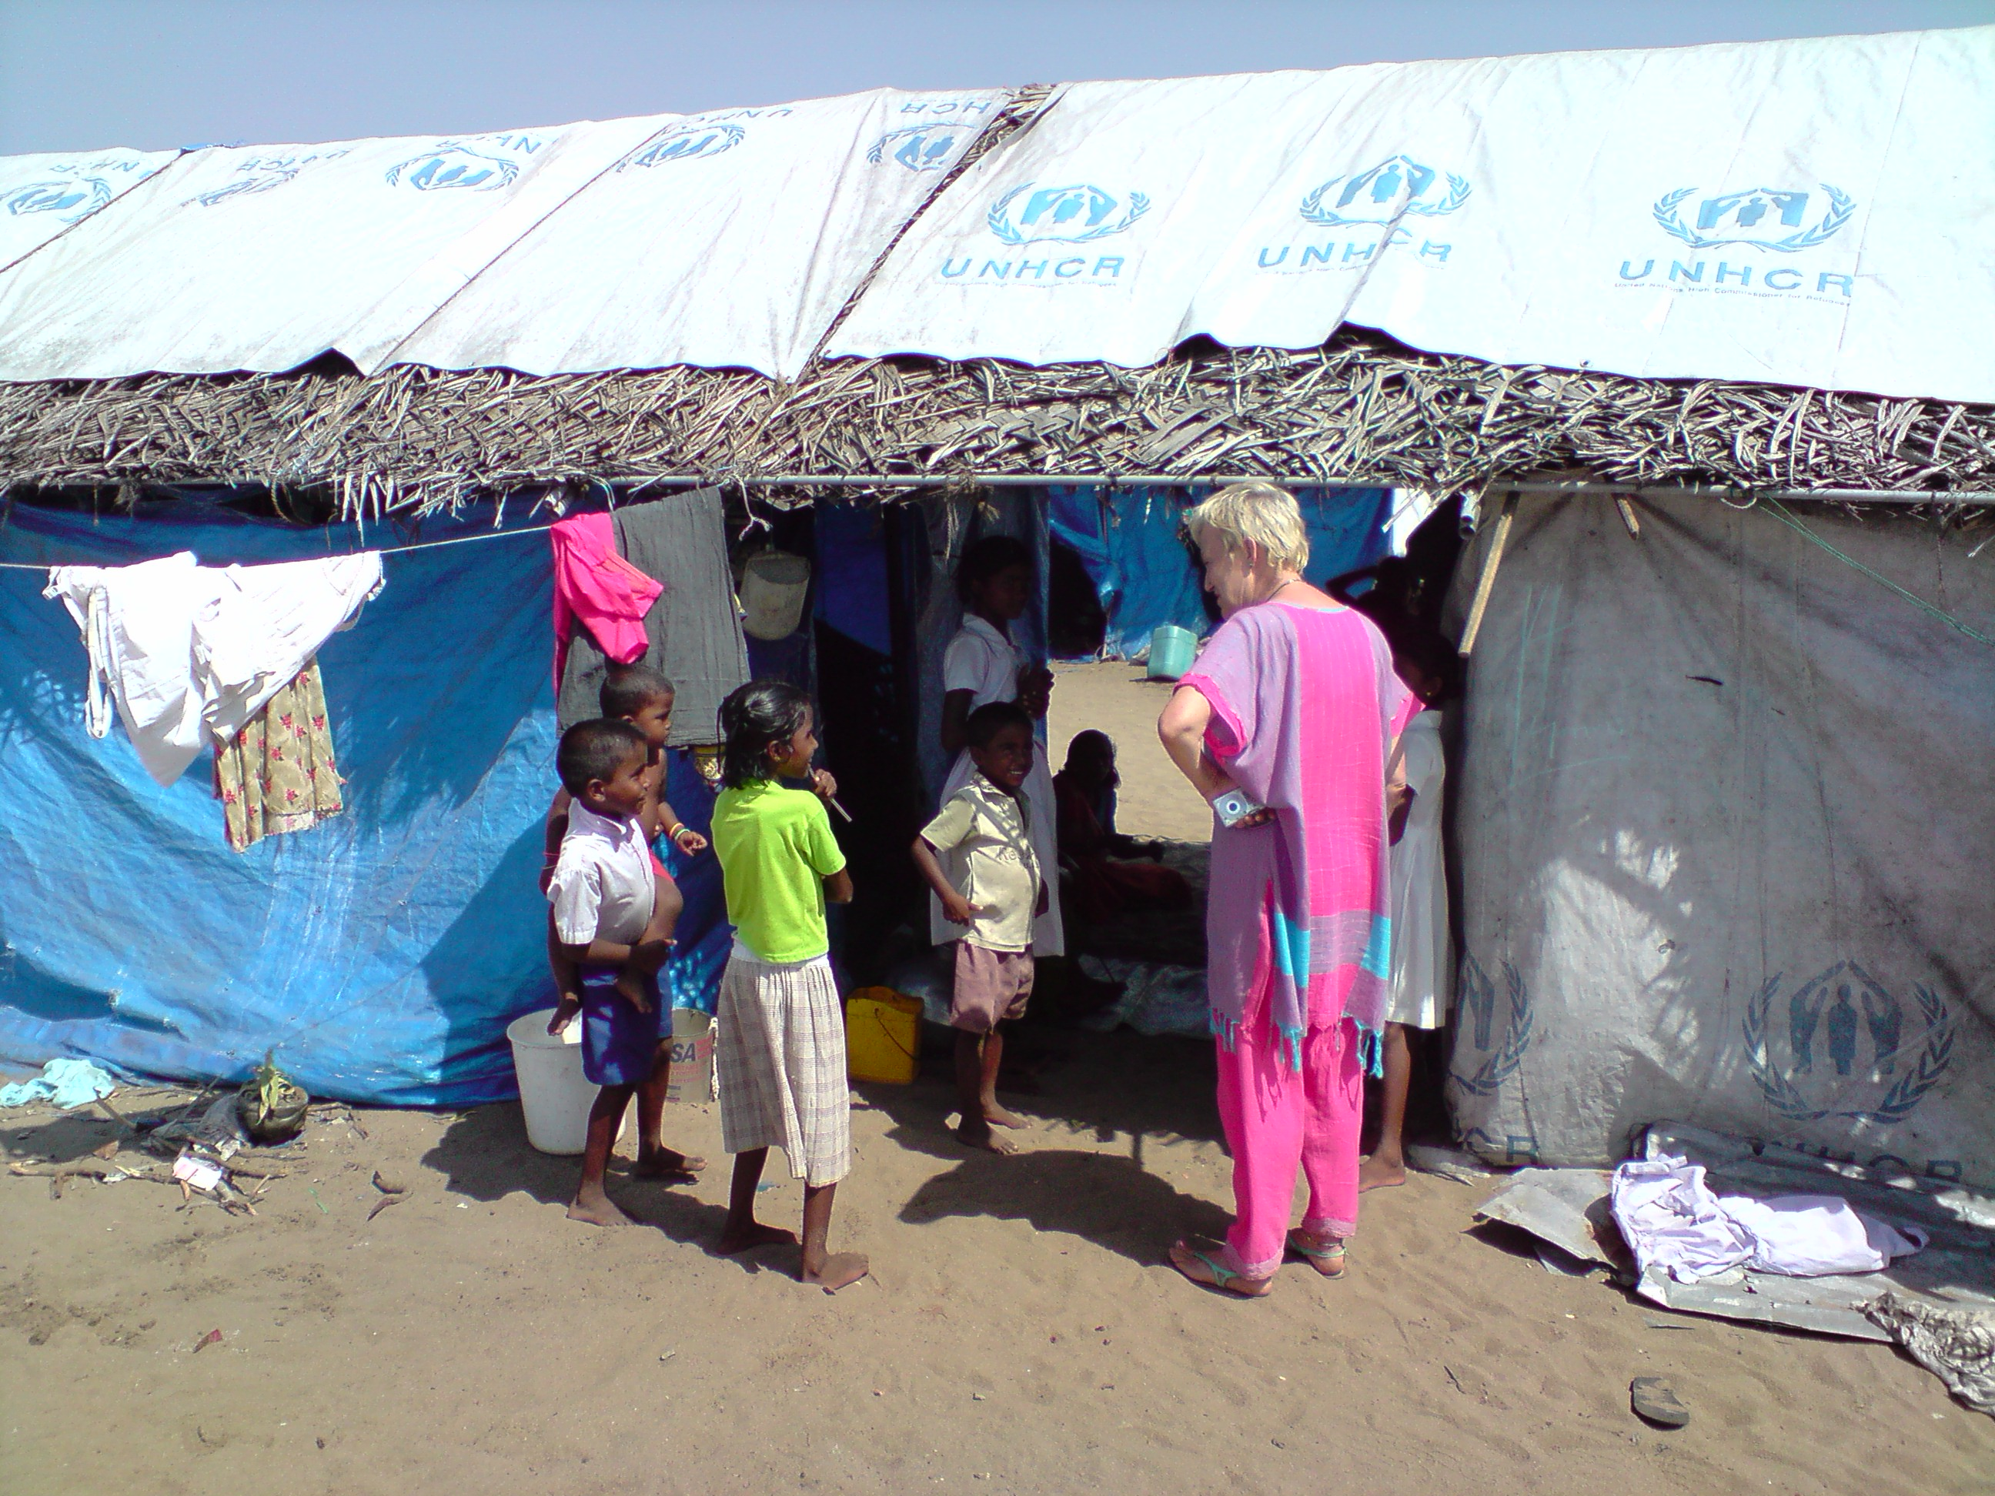
Our Trustees spent a day in the camp and were able to provide some basic necessities; buckets with lids for collecting water, badly needed toiletries and sanitary equipment, clothes for the children bought en route in Akkaraipattu and a donated bicycle The camp comprised 170 adults and children living in tents with only the most basic of facilities. Fresh vegetables were delivered once a week by an NGO. Of the 45 families, nearly half have only one parent. It was a distressing scene and we are planning to provide further assistance as best we can through the local NGO in 2009.

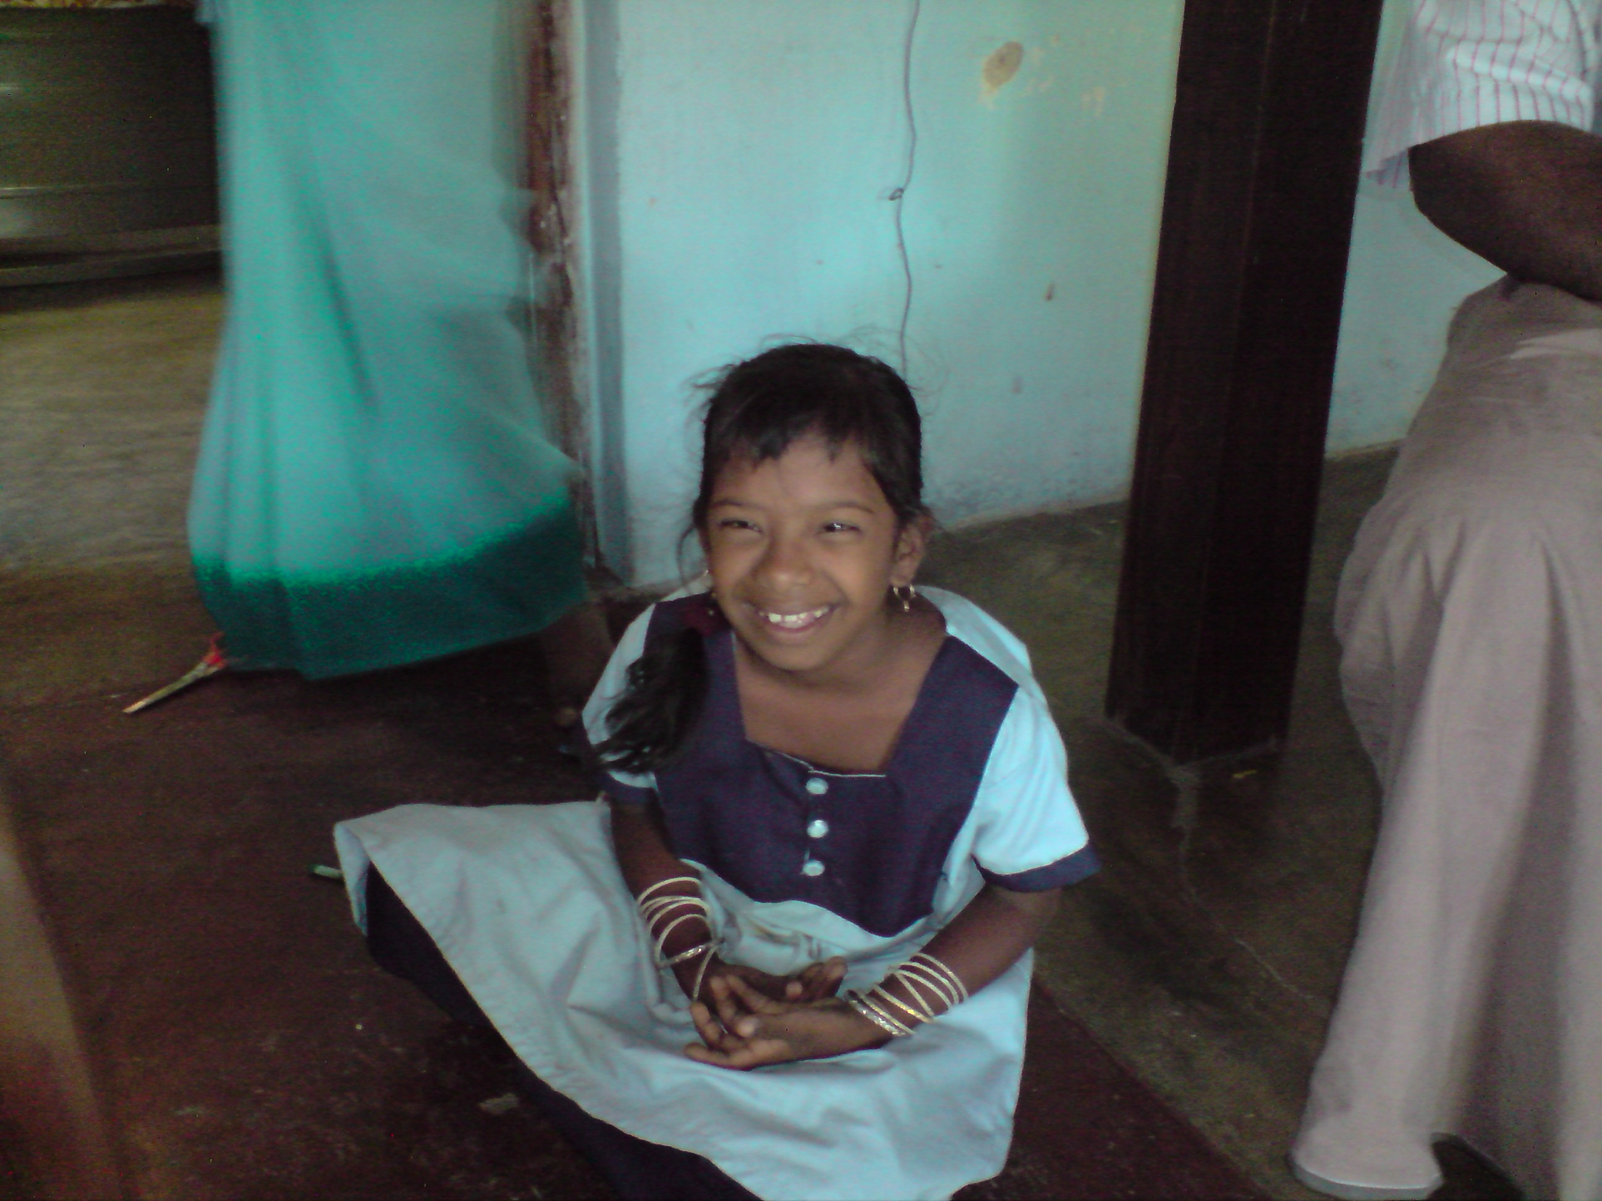
After our trip to the camp, our Trustees visited a small home for 12 disabled orphans in Vellichenni. The needs of this home are substantial but top of the list is equipment for a play area. The carers, who are doing an amazing job in very difficult circumstances, explained that the children needed play equipment to encourage them to use their limbs and develop their mobility. As existing facilities were very basic, the children spent most of their day in the home. If circumstances permit on our next visit, we have undertaken to fund the purchase some play equipment to give these wonderful children a little bit of fun.

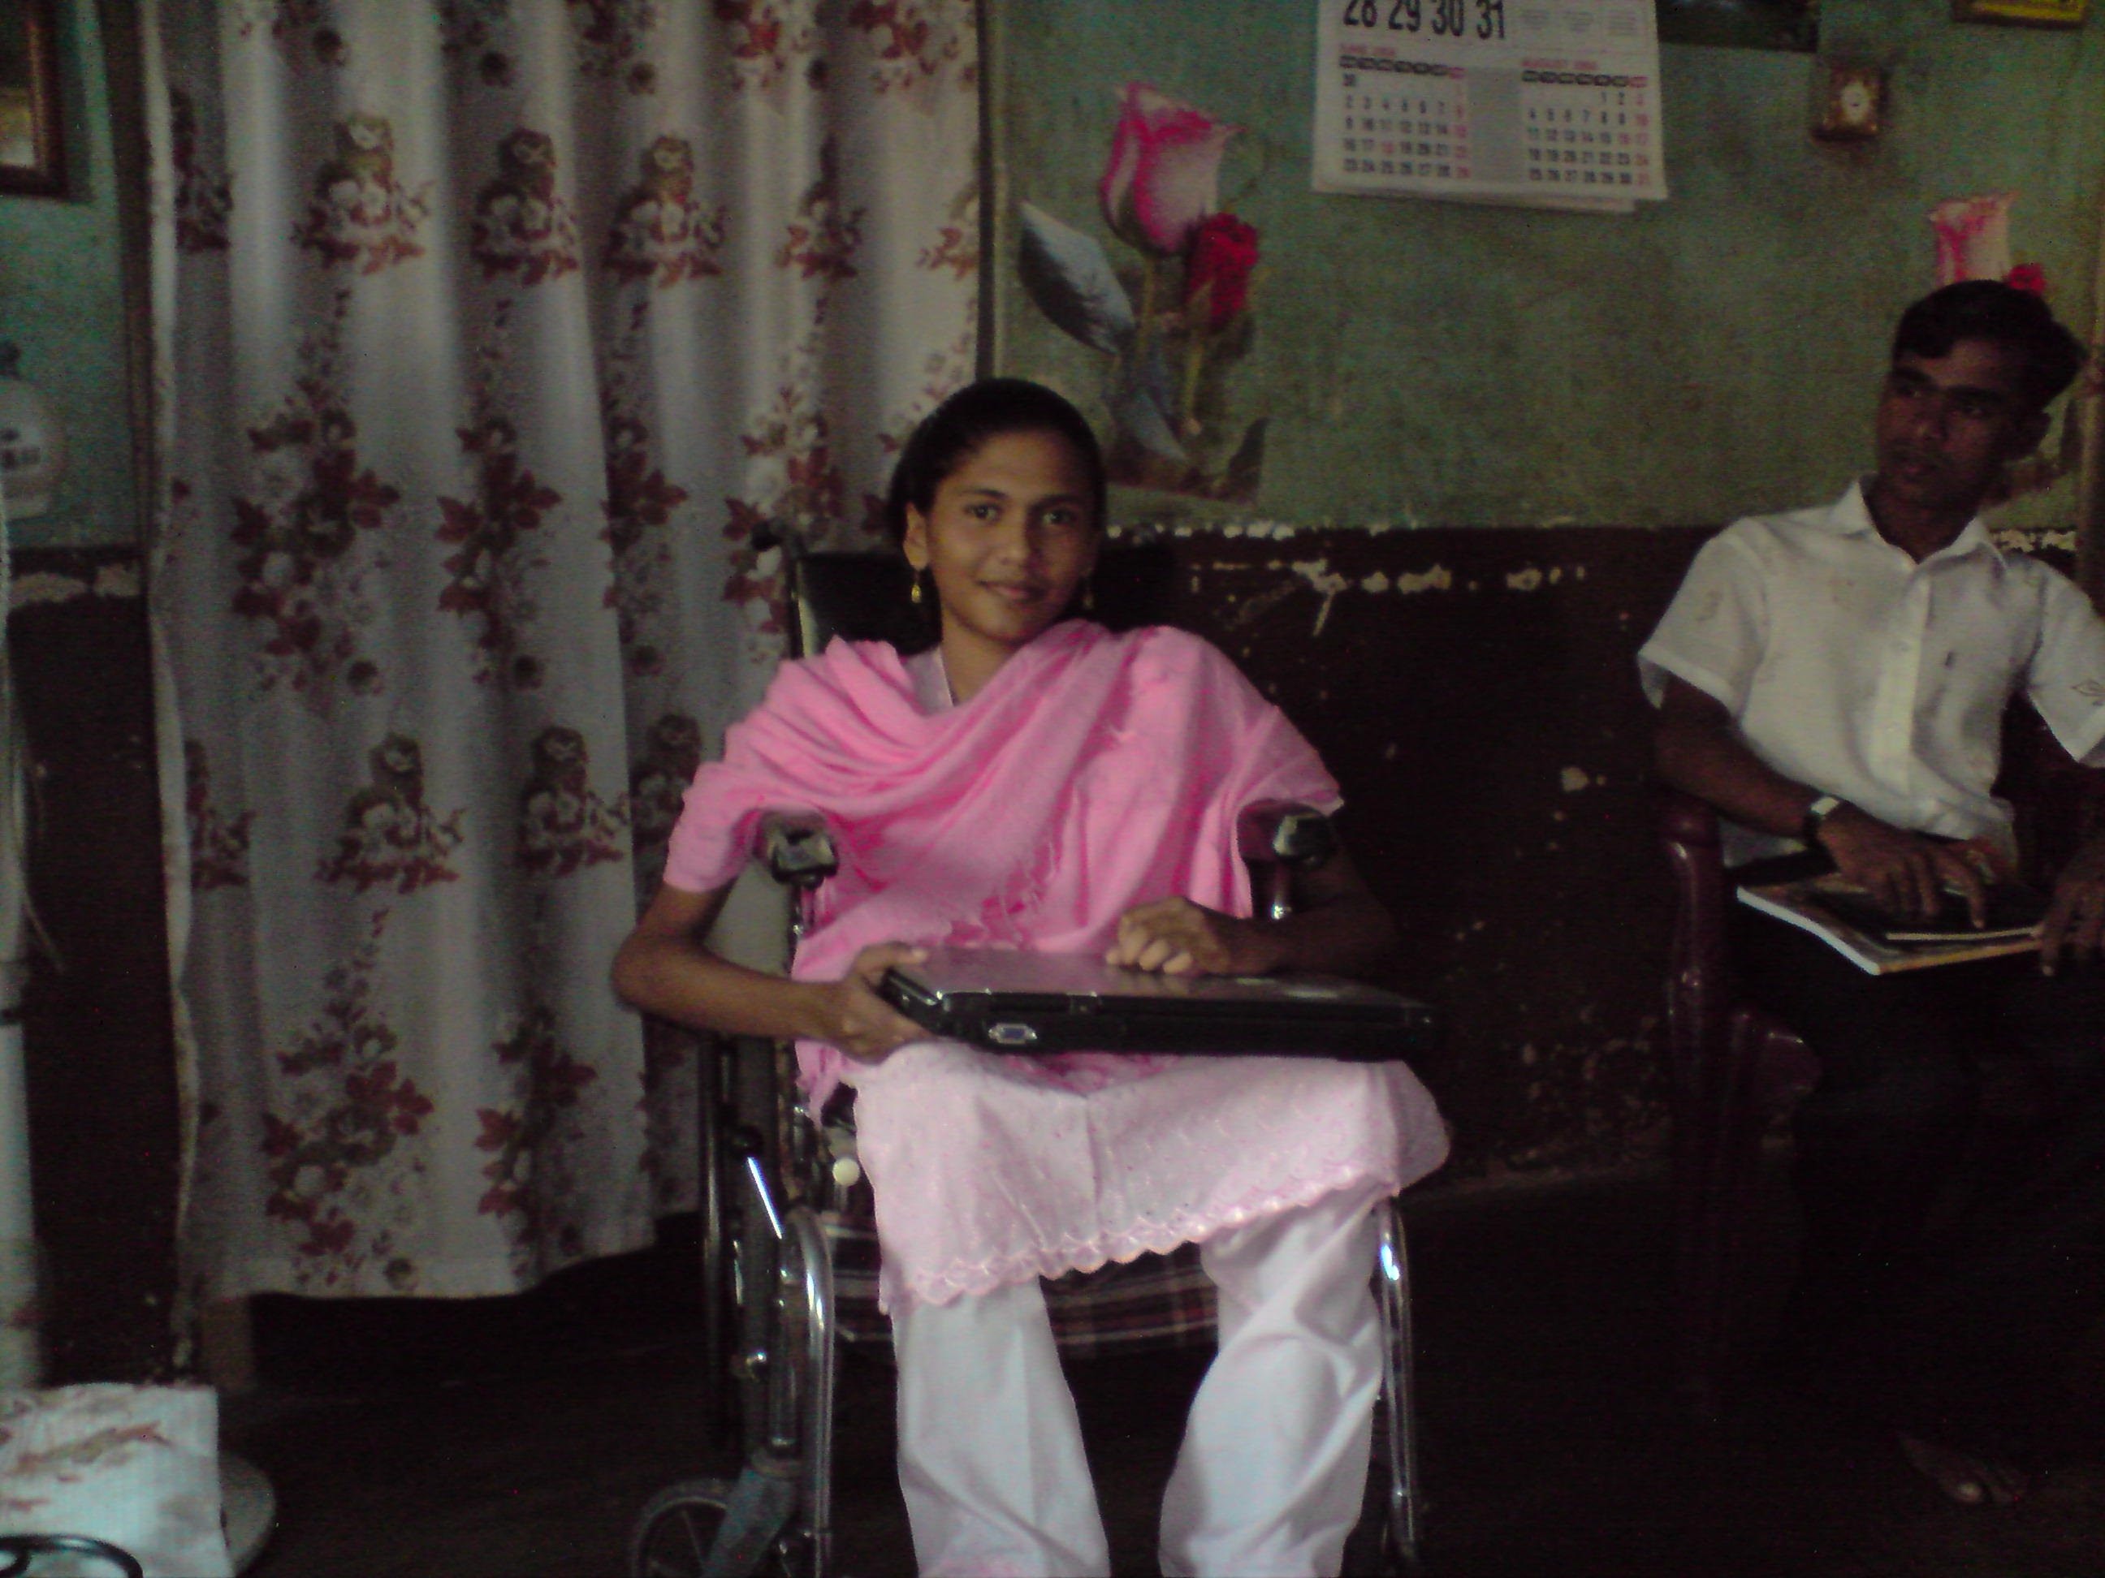
There was one uplifting moment during our Trustees trip North. Annette had told them about an 18 year old girl who, although disabled from birth, was bright and cheerful. She was undertaking computer studies at a local school but had no access to a computer. Our Trustees had kindly been donated a laptop which they were only too pleased to present to the young lady. It is impossible to express how pleased this very shy young lady was when handed the laptop. It was a truly humbling experience for all present. HELP is most grateful to Nicola Gale for her donation. The laptop has gone to the most worthy of causes…

Thirikuvil Hospital

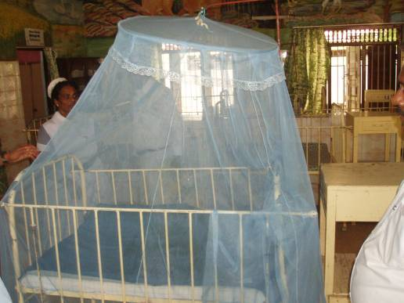
In the course of the year, we have continued to support Thirikuvil hospital where HELP began its work and have been pleased to see the progress that has been made. A large Italian NGO has funded construction work on the fabric of the building but equipment remains in short supply. Through HELP, the hospital has acquired wooden benches, televisions for the waiting room and paediatric ward, mosquito nets and saline drip holders for beds, a glucometer, water dispensers, overhead fans, dining tables and kettles for the male and female wards.

We were proposing to raise money to help equip the hospital’s maternity ward which remains a shell but we understand some government funding may be available. Our Chairman is in contact with the hospital staff on a regular basis to establish their priority needs and we intend to continue our support throughout 2009.

We hope the above gives some indication of where our donors funds are going but if you would like any further details either about HELP or on the individual projects, please do not hesitate to contact us at drvipt@yahoo.co.uk or visit our website www.helpingeastlankaprogress.org.uk
And if you know any friends or family who would be keen to donate, please feel free to contact us….
With thanks again for all your continued support.
Dr Vip Thiagarasah
Mrs Viji Viyakesparan
Alan Ball
Andrew Schneidau
Senthu Viyakesparan
November 2008

