ANNUAL REPORT 2015
We are very pleased to provide the 2015 report on HELP’s activities in what has been another very successful year. Summarized below are the main achievements, the latest status of the projects and our aims for the year ahead. We hope you find it of interest.
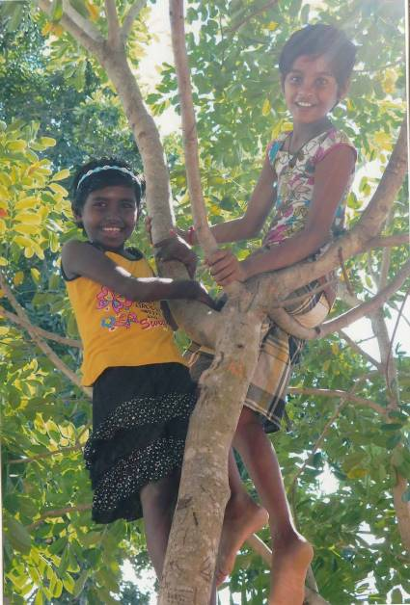
Amman Mahaleer Girls Home
HELP has been supporting the Amman Mahaleer Girls Home in Akkaraipattu for the past nine years. The Home provides support and a safe haven for 45 girls aged 5-18. When we first visited back in 2005, the conditions were very poor with the girls sleeping and eating meals on the floor of the Home. In those early years, we were pleased to be able to help improve the girls’ living conditions through the provision of furniture, beds, mattresses and school kit. In 2010, the girls moved into a new building which offered a brighter future, but unfortunately the funding ran out before construction was completed. HELP has since financed the building of a new kitchen/dining area for the girls and equipped it with chairs, tables and cooking equipment. We have also arranged for the Home to be connected to the electricity system and have installed a water tank, internal shower and toilet facilities and ceilings and fans to the top floor bedrooms, which were open to the roof. Our volunteers in recent years have decorated the girls’ bedrooms and equipped the rooms with fans, cupboards and mattresses. In 2014, the Thomas family kindly provided funds to enable the Home to acquire a ‘tuk-tuk’, which they use for daily shopping in the nearest town and for running children to hospital etc.
We are pleased to report that we have been able to continue our support to the Home and the girls throughout the year due to your generosity. In addition to providing a monthly bursary of Rps 40,000 (c £200) to assist with food and utility bills, we provided Rps.54,000 (c£270) in January to buy new clothes for all of the girls and Rps.45,000 (c£225) to buy new school materials such as exercise books, colouring books, instruments, pens, pencils, files etc. We will aim to do the same in January this year if the funding is required.
Sewing Centre Training Scheme
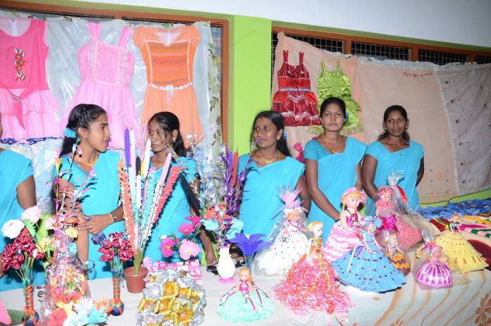
Three years ago, we set up a sewing centre training facility at the Home for single mothers in the local village and for the older girls in the Home. We arranged for the purchase of five Singer (pedal) sewing machines and material, and provided funds to hire a teacher (which we continue to fund). The aim of the training scheme has been to give the single mothers and older girls a vocational skill to help them generate a livelihood when they leave the orphanage. There are currently 25 local women and older girls from the Home learning dressmaking, embroidery and other sewing skills on a six-month course. During the visit in April, the trainees provided a small demonstration of the saris, kameels and clothes that they had produced. The quality of the work was astounding. HELP is delighted to continue its support for this very worthwhile initiative.
Micro-Finance Loan Facility
To help the girls and single mothers to set up their own businesses and generate their own income, we established a small micro-finance loan scheme in 2012 which provides loans to the trainees when they finish the course to enable them to acquire their own machines. The loans incur a small interest charge of 1% per month. This has been a small, but incredibly transformational initiative, and we are very happy to continue to support it throughout 2016.
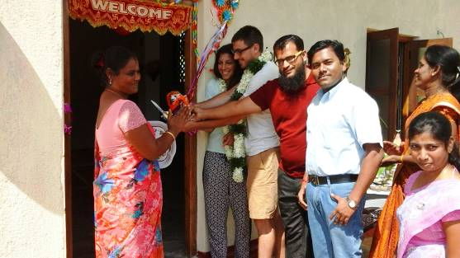
Vocational Training Centre
Our major expenditure this year has been on the construction of a small extension to the Home which will provide space for the sewing centre and for additional educational studies to be provided for the girls. The Home already arranges IT lessons with computers that we purchased a few years ago. We are very grateful to Mr Vamadevan, the Principal of the home for his continued dedication to the children, and to our great friend Munas for managing the construction of the Training Centre. We would also like to thank Natasha and Kevin, two of our volunteers, who kindly opened the facility on our behalf in July.
Sponsorship Opportunity
Mr Vamadevan has recently set up individual saving accounts at a local bank for all 45 girls in the orphanage with the aim of building up savings of Rps 50,000 (c£250) for each girl by the time they leave at 18 to help pay either for their further educational studies or to give them a start in adult life. Another small charity (www.gnanam-foundation.org) has agreed to support 22 of the girls, contributing Rps1,000 per month (£5) into the girls’ savings accounts. Mr Vamadevan is now looking for sponsorship for the other 23 girls. If anyone would be interested in this scheme, please contact our treasurer (alanball333@gmail.com) for further details. HELP would be very happy to administer this on behalf of any potential donors.
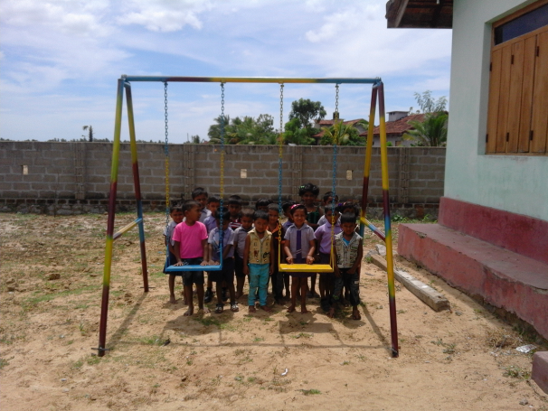
Amman Pre-school
There is a small multi-faith pre-school (children aged 3-5) attached to, and run by, the girls home, which we have supported for a number of years though a small bursary to meet the teachers’ salaries and the purchase of equipment (books, tables and chairs). When we visited in 2014, the teachers at the school asked whether HELP would be able to arrange for the classroom to be connected to the electricity grid and whether we would be prepared to fund a secure cupboard to keep the children’s workbooks and certificates safe from rodents (as they were being kept in bags pegged to a washing line in the classroom). Again with thanks to Munas, we were delighted to provide both this year. We have also installed a small swing for the children to keep them amused at playtime…
The “Little Flowers” after-school classes in Thirikuvil

As many of you will be aware, one of HELP’s longstanding projects has been the funding of a small teaching facility that provides daily after-school classes for junior school children in the village of Thirikuvil. It was set up a number of years ago by our very good friend, Mr Gunapalan, who provided accommodation for us when we first visited Sri Lanka in the wake of the tsunami in early 2005. The makeshift school, built by Mr Gunapalan and friends, was originally based on spare land adjoining his house. Unfortunately, this land was returned in 2013 to its owner and the school was moved and rebuilt further down the street.

The school remains remarkably successful, with nearly 100 of the poorest children in the village attending 2-hourly classes in Tamil, Singhalese, English, Mathematics and Social Science daily from Monday to Friday each week. Mr Gunapalan was delighted to report in October that all four students entered for the Grade 5 government scholarship were successful, including a young girl who lost her father when she was one. She achieved the highest score of 167. These students will now be granted full scholarships to continue their secondary education. The results reflect enormous credit on the dedication of Mr Gunapalan and his small teaching team.

We discussed the future plans for Little Flowers with Mr Gunapalan on the visit in April. We will, of course, continue to provide the funding for equipment and to pay the salaries of the seven teachers (total cost of c£150 per month). But the major concern over the past couple of years has been the land on which the school is situated. For the third year running, Mr Gunapalan has had to return the land on which it was sited to its owner and to relocate and rebuild it elsewhere. The school was recently rebuilt on land in front of Mr Gunapalan’s own house, but this is likely again only to be a temporary arrangement. A permanent site is required, but Mr Gunapalan has not, to date, found anywhere suitable at the right price. We will continue to support his project and hope to be able to fund the land purchase when a suitable site is found. This is likely to be in the region of £3,000.

Swami Vipulananda Boys Home
Along with the girls home, another of our more longstanding projects has been support for the Swami Vipulananda Boys Home in Akkaraipattu, which provides a haven to 15 boys orphaned by the tsunami and the civil war. We provide a small monthly bursary which covers the food bill of the Home. We were unable to meet the Principal on the recent visit, but we are in contact through our Chairman’s father, who phones regularly.
Aims for 2016
The Trustees will be visiting Sri Lanka again in 2016 to oversee the effective management of each of the above projects and will fund any land that Mr Gunapalan identifies as suitable for a permanent base for his teaching facility. We will continue to support all of the existing projects described above, but do not foresee any expansion into new projects in the year ahead – the vocational centre has stretched our limited resources….
Hopefully, you will see from the above that your generous donations are making a real difference to a number of children, families and communities. As you will be aware, all donations received go directly to our projects - there are no administration costs incurred by the charity.
We hope the above has been of interest, but if you would like any further details about HELP or of any of the individual projects, please do not hesitate to contact us at drvipt@gmail.com or visit the website www.helpingeastlankaprogress.org.uk. We are, as you know, a very small charity supported by around 70 regular donors so if you know of any friends or family who might be interested in contributing either a one-off donation or small monthly contribution, please pass on our details.
Our Just Giving account can be found at: http://www.justgiving.com/helpingeastlankaprogress/Donate and our bank account details are as follows:
Bank: Bank of Ceylon (UK) Ltd
Sort Code: 40-50-56
Name: Helping East Lanka Progress
A/c no: 80008300
Also, to ensure that we are being as tax efficient as possible, it would be great if all existing regular donors could complete the Gift Aid form in the Annex to (re)confirm that they are content for HELP to reclaim the tax on their donation.
With thanks again for all your continued support.
Dr Vip Thiagarasah
Mrs Viji Viyakesparan
Senny Viyakesparan
Alan Ball
Andrew (Pug) Schneidau
December 2015
HELP is registered with the Charities Commission in the UK number 1111363.
Gift Aid Declaration

If you are content for your donation to be treated as Gift Aid, please complete the following declaration:

I want Helping East Lanka Progress to treat the above donation as a Gift Aid donation.

Signature (s)………………………………………………………………………………..

……………………………………………………………………………………………...

Your address …………………………………………………………………………………
……………………………………………………………………………………………….
Date…………………………………………………………………………………………

Notes:

- You must pay an amount of income tax and/or capital gains tax at least equal to the tax that the charity reclaims on your donations in the tax year (currently 28p for each £1 you give).
- You can cancel this declaration at any time by notifying the charity.
- If you pay tax at the higher rate you can claim further tax relief in your Self-Assessment tax return.
- Please notify the charity if you change your name or address.

If content, please give your e-mail address below. The Trustees of Helping East Lanka Progress (Registered Charity Number: 1111363) undertake not to use this for any purpose other than correspondence with you on matters directly relating to the charity. This will greatly facilitate our administration. The address will not be forwarded to any third party.
e-mail address …………………………………………………………………………………………………………

Please send this form to: Senny Viyakesparan, 47 Broadfields Avenue, Winchmore Hill, London N21 1AG

