Report on Relief provided for Flood victims.
Fund Provided by : Help East Lanka Progress (HELP) – UK
Implemented organization : Amman Children Home – Amparai, Srilanka

Large number of families sustained losses of their belongings and means of income they earned through paddy cultivation due to flood caused by heavy rain in the eastern province and they having displaced of their residences and had to seek refugee in Welfare Centers. As a result of heavy and continuous raining, tanks and water reservoirs were damaged and paddy field were inundated by flood.
Taking into consideration of the plight of the people displaced and stayed in Welfare Centers in Ampara district, the Organization Help East Lanka Progress (HELP) – UK came forward to the rescue for providing relief worth Rs.150,000/- for the affected people through Amman Girls Home which implemented the program
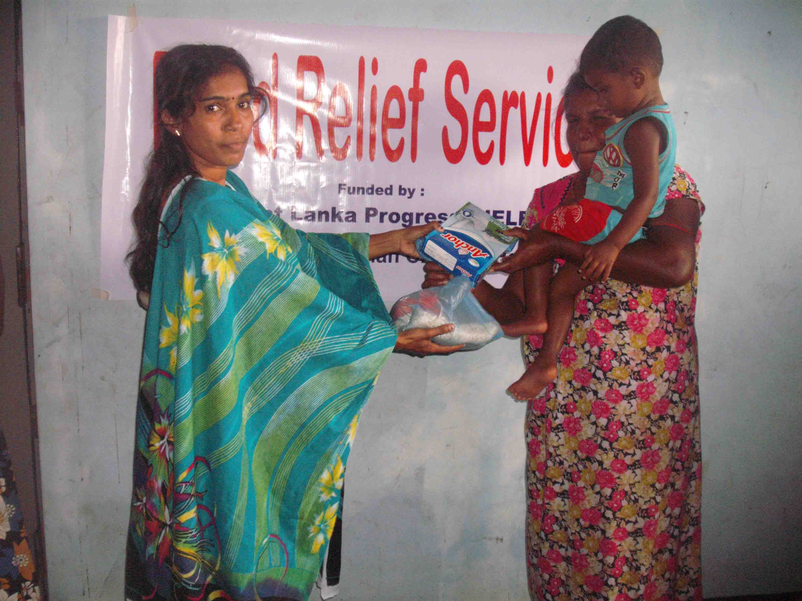
(i). The people affected by flood lost all food items they had for consumption. Hence they were unable to feed their children and undergone immense difficulties. They were in hungry and longing for food. We provided food items such as Anchor, Biscuit for children utilizing the fund.
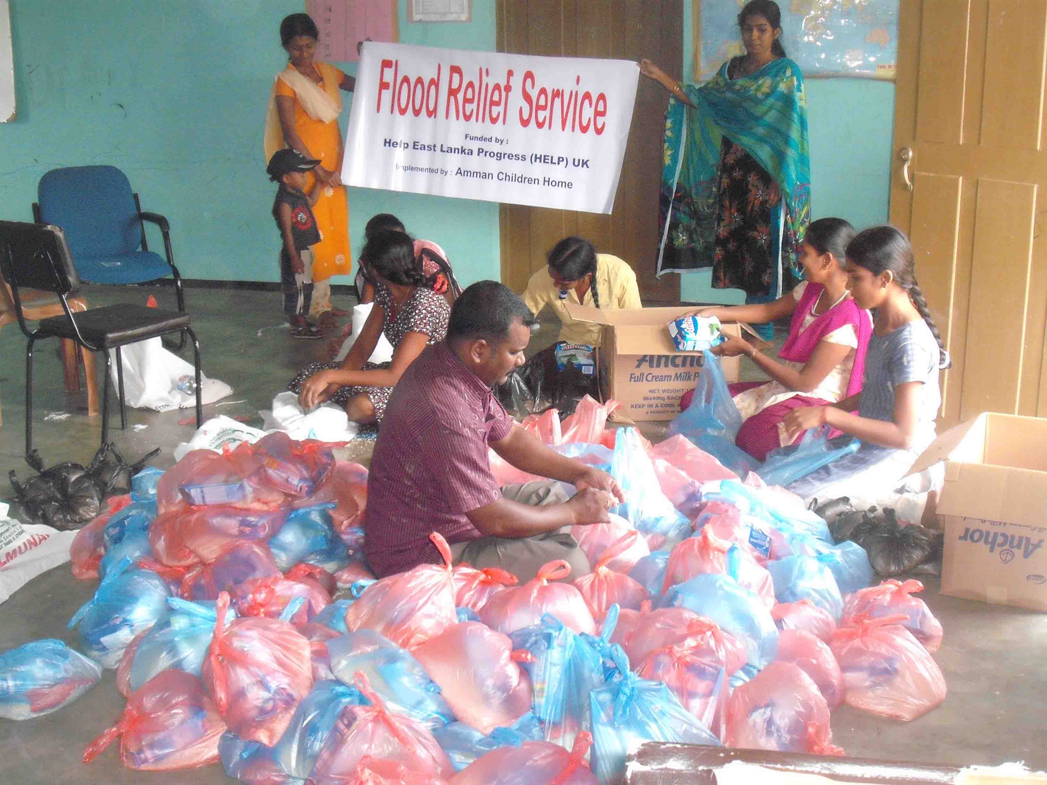

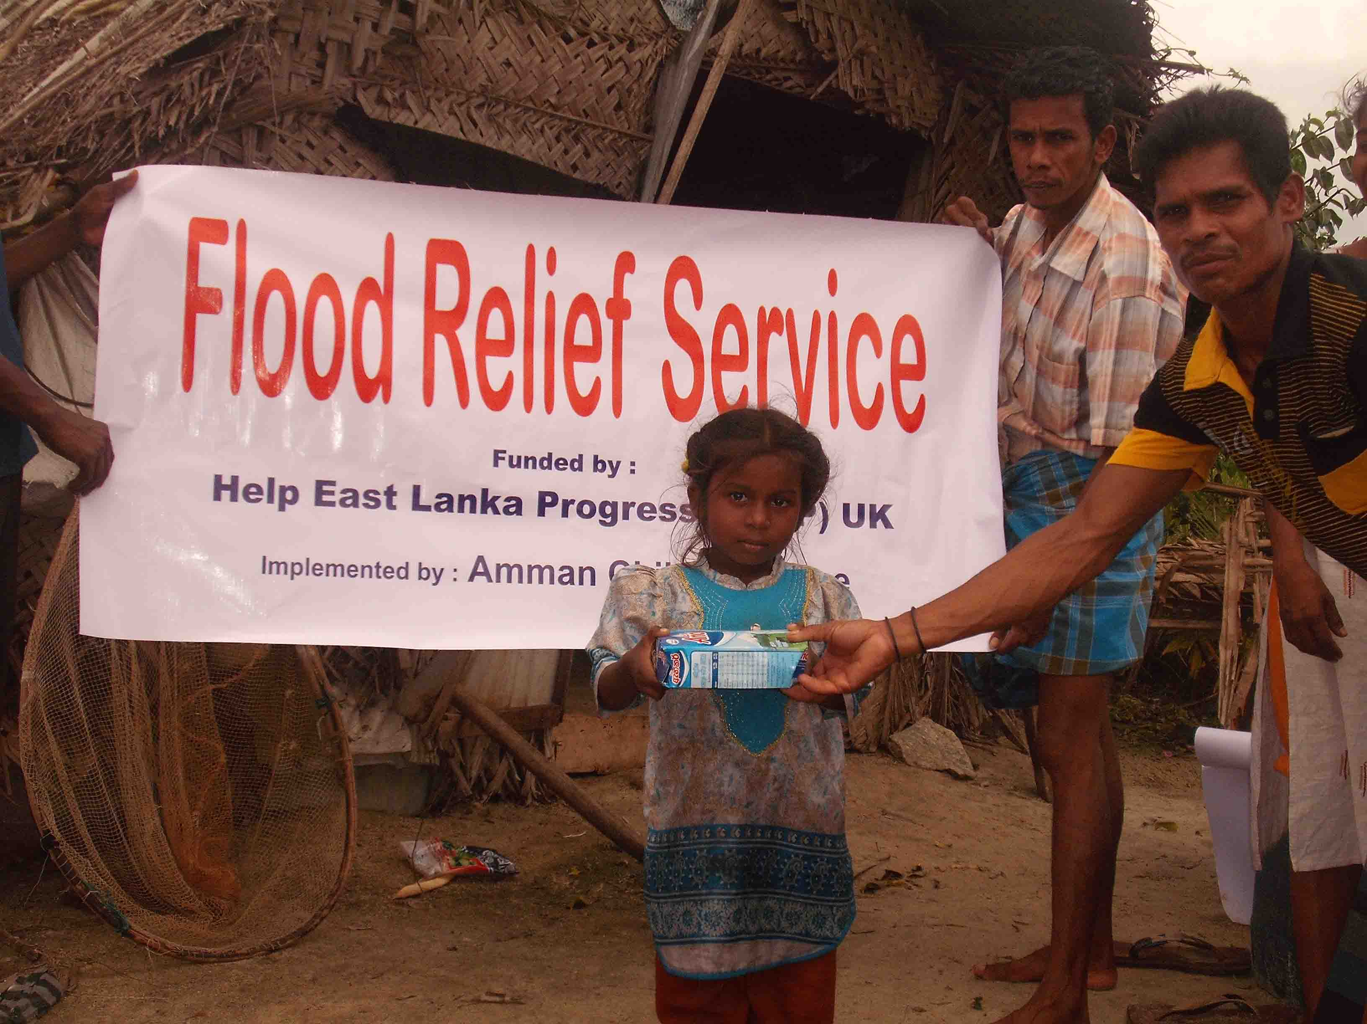

(ii) People faced problem caused by increased mosquitoes due to flood and stagnated flood water. Specially the children were affected and their parents were unable to purchase Mosquito Nets to save their children. We therefore purchased Mosquito Nets specially for the children aged under one years of age.
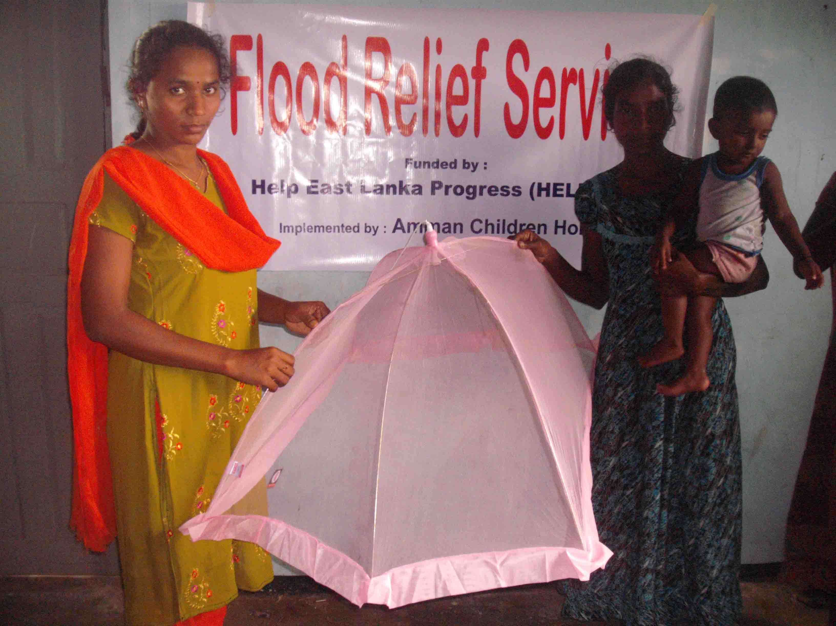
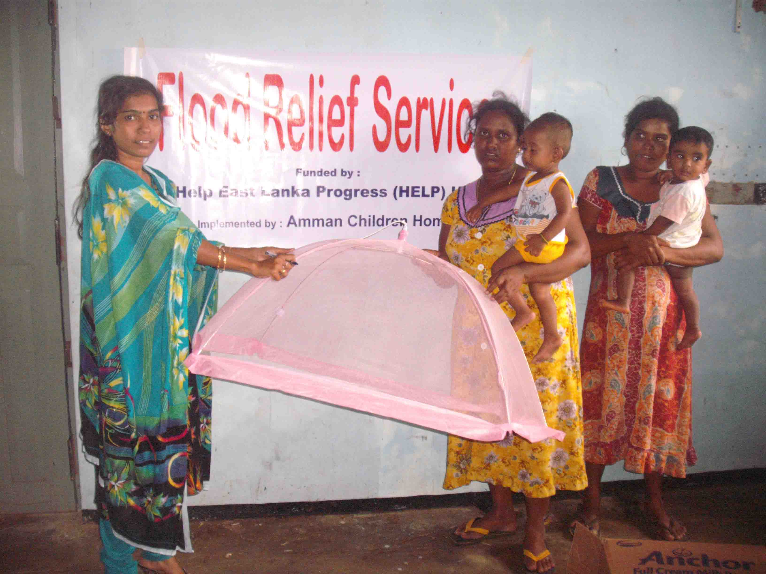
.

iii. STATEMENT OF EXPENDITURE

